

**Mitsubishi SRK 13CJK Heavy Industries 1 Ton**

**Rs. 48,000/-**

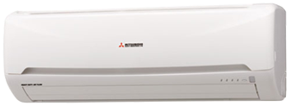

**Product Features**

* Self-diagnostic Function
* 15M Long Distance Airflow
* super quiet mode
* comfortalble sleep mode
* evaporator self-cleaning

**Specification**

**Type** Wall Mounted Split AC

**Cooling (Btu/h)** 22000

**Voltage (V)** 220-240

**Power Input (W)** 3100

**EER (Btu/W-h-W/W)** 5.0-3.50